(1 mark, file to be edited: Q3.c)
Your program allows the user to enter an array of ‘n’ positive integer numbers (n > 0), where ‘n’ is entered from the keyboard (STDIN).
Program to display max of odd numbers
Below is an example when ‘n’ = 8; elements: {6, 5, 13, 14, 11, 18, 9, 10}; Ouput: 13

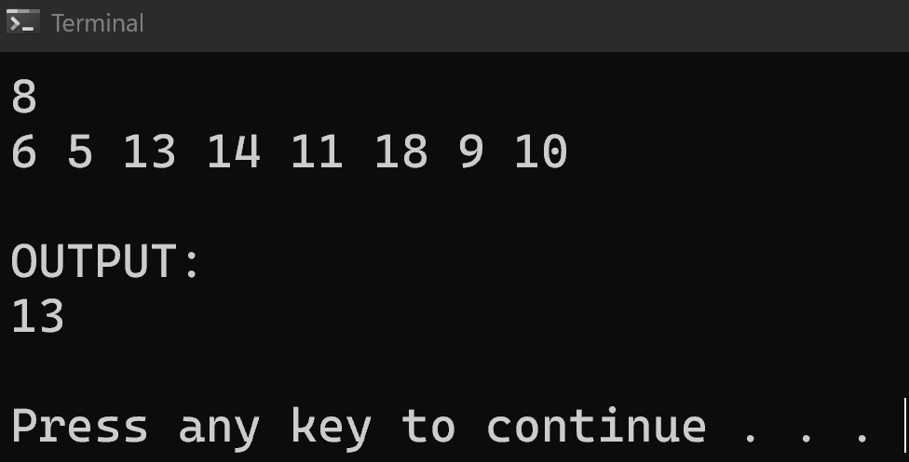

Below is an example when ‘n’ = 4; elements: {4, 8, 2, 12}; Ouput: -1
